**FindSpot Web App**

Group 17:

* 1604261 MULLER MATTHEW
* 1602399 FRASER OWEN
* 1600389 CASTILLO RAFAEL
* 1507972 HASS PIOTR
* 1607046 MUIR JAMIE

***App Concept:***

A user-updated web application which finds parking spaces which meet certain criteria, such as price of parking and location.

Users can provide feedback on locations, submit locations which are not displayed and report locations falsely showing parking places.

The objective of this application is to have a tool that helps the user find a free or payed parking spot as well as rating and sharing information about them while avoid losing time or getting yourself in trouble.

After marking that you have parked at a listed or unlisted spot the app will place a tracker which can be used to find directions back to the vehicle. If the parking spot has timing restrictions then the user will have the option to start a timer until the time they have to move the vehicle.

***Context:***

FindSpot is a free platform for drivers and/or passengers attempting to find reliable and reviewed parking in a congested or unknown area while providing relevant information such as time restrictions, congestion times, and other useful user-submitted data.

In a city where parking is a major issue and people are constantly getting tickets or running late, the need for a service with the ability to help you discover open & nearby parking relevant to your location. The purpose of the app is to build a community that shares i to achieve a complete and accurate application that will contain most of the free and paid parking areas in the city.

***Users & Demographic:***

The apps user base will primarily be made up of young drivers, visiting drivers who might not be local and/or regular passengers who direct the person driving them. Examples like international and exchange students, tourists and others on city trips and other vacation or vocational travel.

As Aberdeen is a city with a diverse population in constant change with incoming and outgoing visitors it makes the perfect city to develop an app requiring a large amount of new users unintroduced to the spots out of their usual way.

***Content:***

The main content delivered by the web site will be focused around a map of parking spots close to the GPS location taken from the phone of the user.

From this map you can extrapolate local parking markers which deliver relevant information regarding the spot and its terms of use if applicable, along with user submitted notes and reviews.

The app will be collecting user data to calculate location and to allow log-ins and attributed reviews. It will also be running an API to interact with Google Maps.

Our server will be hosting the congregated data from city layouts along with user-submitted data, and all of the user account information.

***Web Service Dependency:***

GoogleMaps: ---https://developers.google.com/maps/documentation/javascript/reference/3.exp/

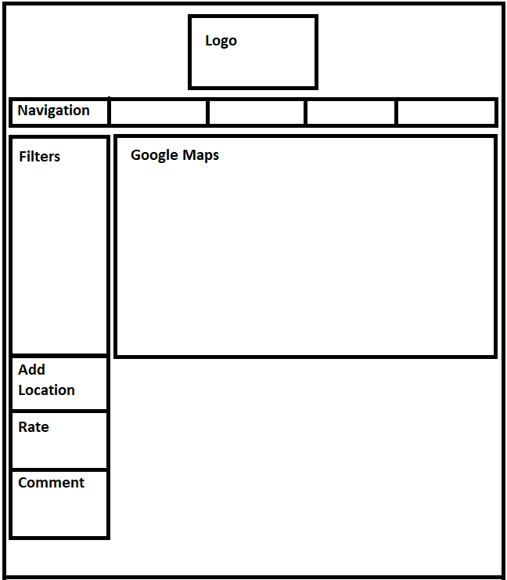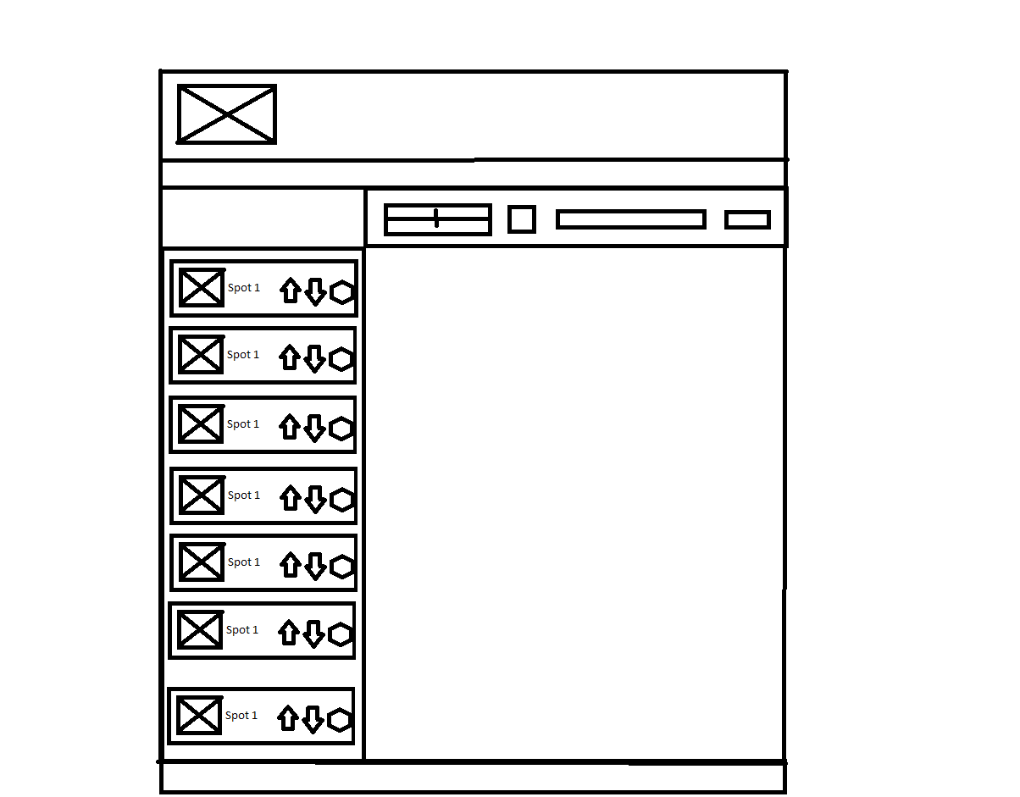***Interface Wireframe:***

*Left: Expanded Spot list with review functionality and full screen map.*

*Right: Filter Search List with navigation bar, and cornered map.*

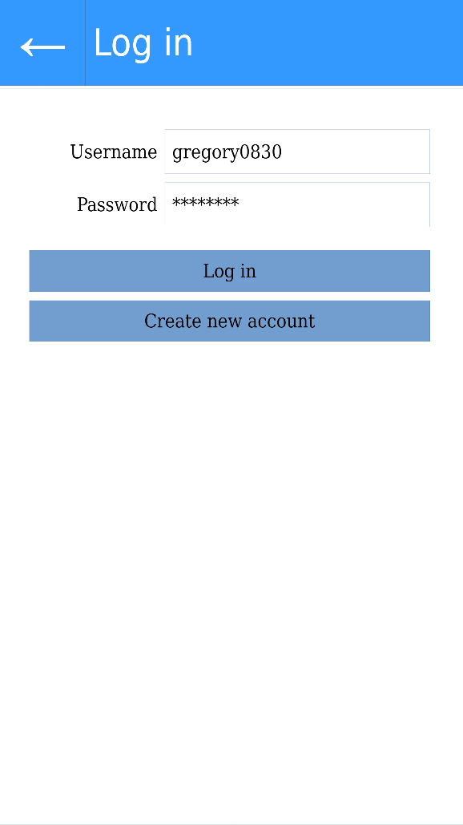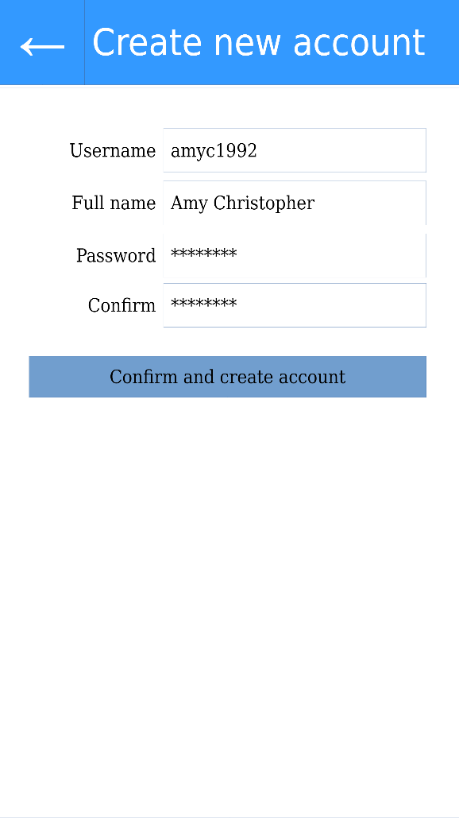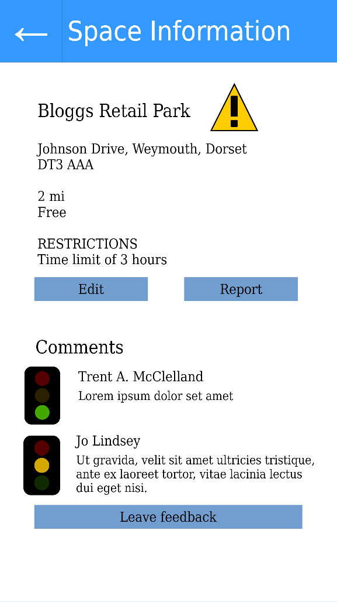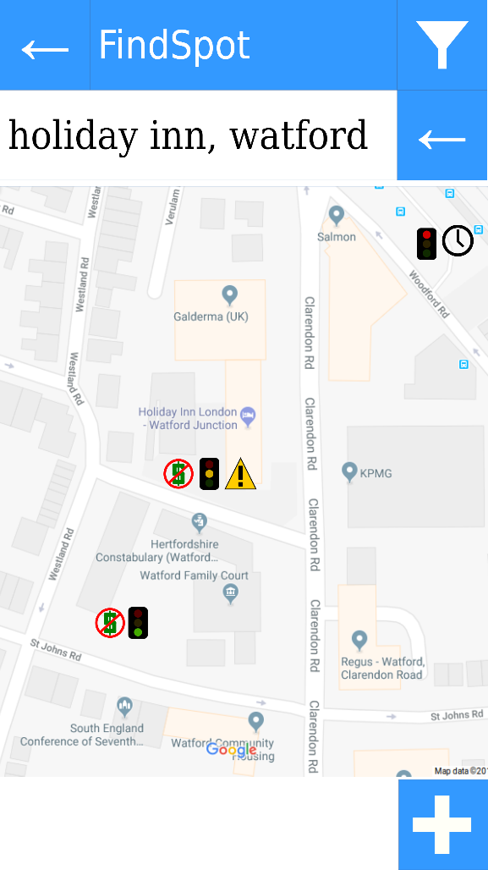 ***User Experience:***

***s4 Screens of the mobile wireframe***

***Top-Left:*** *Main screen showing the Google Maps interface, along with several example parking spaces with associated warnings and average review scores using traffic light icons.*

***Top-Right:*** *Information on space selected from Map, includes restrictions, cost, distance, audit & review options, and feedback.*

­­­The web page is largely covered by a rendering of a map of the area surrounding the users read location (If turned on). The user can then adjust the automated selection or find their initial location via the search bar. After locating the user the map will display any parking data nearby, which can be sorted with a list of filters and the result will be output to an expandable list to the left hand side that gives the user the option to flag, review, up/downvote or add additional restrictions and descriptions.